The Recitation Contest 暗唱大会用の文章を次の3つのうちから選びなさい。
各文章の音声は今宮ホームページの今宮ブログ「1年生英語お知らせ」の中にアップしています。各自、メディアに取りこんで、何度も繰り返し聞いて練習しましょう。（リンク先の英語と暗唱大会用の文章は若干違います）
1. The Great Dictator
リンクhttps://www.youtube.com/watch?v=0bOLrMGKkfk&feature=player_embedded#t=28
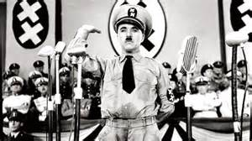
イギリスの喜劇役者チャールズ・チャップリンがヒットラーとナチスを風刺して作った「独裁者」中の有名な演説の一節。独裁者と取り違えられた床屋が、国民に演説をする羽目になるのですが、そこで、愛と勇気をもって独裁政治に立ち向かおう、と兵士達に呼びかけます。

I'm sorry but I don't want to be an emperor. That's not my business. I don't want to rule or conquer anyone. I should like to help everyone if possible---Jew, Gentile, black men, white.
To those who can hear me, I say "Do not despair." The misery that is now upon us is but the passing of greed, the bitterness of men who fear the way of human progress. The hate of men will pass, and dictators die, and the power they took from the people will return to the people. And so long as men die, liberty will never perish.
Don't give yourselves to these unnatural men---machine men with machine minds and machine hearts! You are not machines! You are not cattle! You are men! You have the love of humanity in your hearts! You don't hate---only the unloved hate. The unloved and the unnatural.
Soldiers! Don't fight for slavery! Fight for liberty!

2. I Have a Dream by Martin Luther King, Jr.
リンクhttps://www.youtube.com/watch?v=3vDWWy4CMhE&feature=player_detailpage#t=15
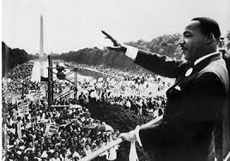
アメリカ公民権運動の指導者、キング牧師がワシントン大行進で人種差別の撤廃を訴えた、あまりにも有名な演説「私には夢がある」のさびの部分です。

I say to you today, my friends…, so even though we face the difficulties of today and tomorrow, I still have a dream. It is a dream deeply rooted in the American dream.
I have a dream that one day this nation will rise up and live out the true meaning of its creed: We hold these truths to be self-evident that all men are created equal.
I have a dream that one day on the red hills of Georgia the sons of former slaves and the sons of former slave owners will be able to sit down together at the table of brotherhood.
I have a dream that one day even the state of Mississippi, a state sweltering with the heat of injustice, sweltering with the heat of oppression, will be transformed into an oasis of freedom and justice.
I have a dream that my four little children will one day live in a nation where they will not be judged by the color of their skin but by the content of their character. I have a dream today!

3．Virginia’s Letter
リンクhttps://www.youtube.com/watch?v=FHmxt8_dQgY&feature=player_embedded#t=6
https://www.youtube.com/watch?v=I4kt3XlP0x0&feature=player_embedded#t=108

友達にサンタクロースなんかいないと言われた８歳の女の子がニューヨークの新聞社に「サンタクロースは本当にいますか？」という手紙を送ります。編集者が社説で、その問いに誠実に答えます。

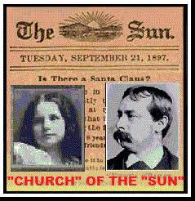
We take pleasure in answering thus prominently the communication below, expressing at the same time our great gratification that its faithful author is numbered among the friends of The Sun.
Dear Editor,
I am 8 years old. Some of my little friends say there is no Santa Claus.
Papa says "If you see it in The Sun, it’s so.” "Please tell me the truth, is there a Santa Claus?
Virginia O' Hanlon
Yes, Virginia, there is a Santa Claus. He exists as certainly as love and generosity and devotion exist, and you know that they abound and give to your life its highest beauty and joy. Alas! How dreary would be the world if there were no Santa Claus! It would be as dreary as if there were no Virginias. There would be no childlike faith then, no poetry, no romance to make this existence tolerable.
No Santa Claus! Thank god he lives, and he lives forever. A thousand years from now, Virginia, nay, ten times ten thousand years from now, he will continue to make glad the heart of childhood.

