【２年動名詞】単元別テスト用問題

例にならい
Step 1
次の ( )内の動詞を適切な形に書き換え、イラストにふさわしい英文を完 成させましょう。

イラスト | 動詞 | 状況の説明
例. | ( play ) | 例）He is my boy friend and he plays tennis well.  We went to the park to play tennis.  We enjoyed playing tennis yesterday.
  1. | ( run ) | This is a picture of sports day in our school.  I was a member of a relay race as the anchor.  I finished and won the race.
2. | (talk) | One day, my father’s friend called him. He talked about his dog. But he stopped to him,  because he was getting on the train.
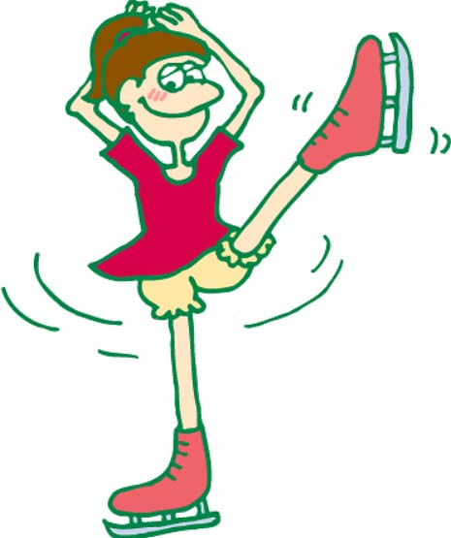  3. | ( skate ) | This is a picture of my sister. Her name is Kumi.  She likes .  She wants to be a good ice skater.
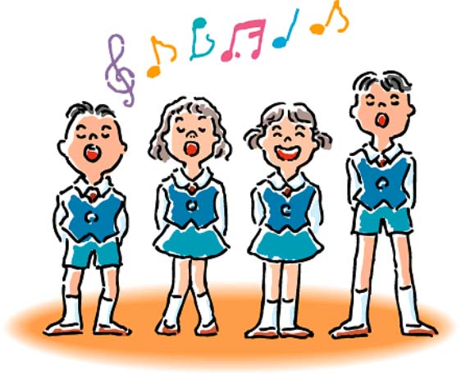  4.. | ( sing ) | I think songs is fun.  So I want to join the chorus contest this year.
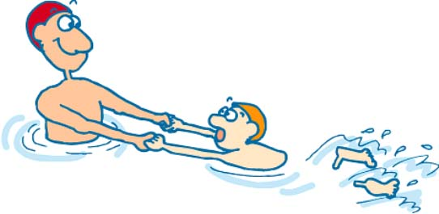  5. | ( swim ) | My brother is good at swimming. I want to be a good swimmer like him.  But is difficult for me.

次の下線部に適切な語を書きくわえ、イラストにふさわしい英文を完成させましょう。
Step ２

  １ | A: What is your hobby?  B: My hobby is the . It’s fun.
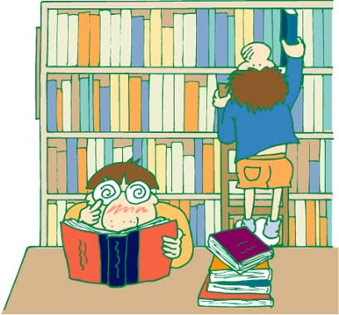  ２ | A: Do you have many books?  B: Yes, I do. I enjoy them every day.

Let’s challenge!
総合的な学習の時間で、仕事体験学習をすることになりました。
そこで、あなたは希望していたＡ社の面接で英語による自己PRを行うことになりました。あなたなら、どのような自己ＰＲを考えますか？例のプロフィールとそのためのメモをもとにあなたの自己ＰＲを完成させましょう。
例） メモ）
My name is Tanaka Hiroko.
My favorite subject is English.
My hobby is playing the piano.
When I’m free, I enjoy watching movies on TV.
In the future, I want to be a pianist.
I like listening to classical music and playing the piano
very much.
名前：田中 広子 好きな教科：英語
趣味：ピアノ演奏
休日の過ごし方：テレビで映画を見て楽しんでいる
将来の夢、就きたい職業：ピアニスト
理由：クラシック音楽を聴くこと、
ピアノを弾くことが大好き

