【３年 分詞・接触節】単元別テスト用問題解答
Step 1
次の英文中の（ ）内の語を適切な形に変えよう。また、〔 〕内の語は並べかえて英文を完成させよう。
The white building [①see / we ] over there is Osaka Castle (② build ) by Toyotomi Hideyoshi long ago. He was a strong samurai (③call) ‘Taiko.’ Many people in Osaka love him.
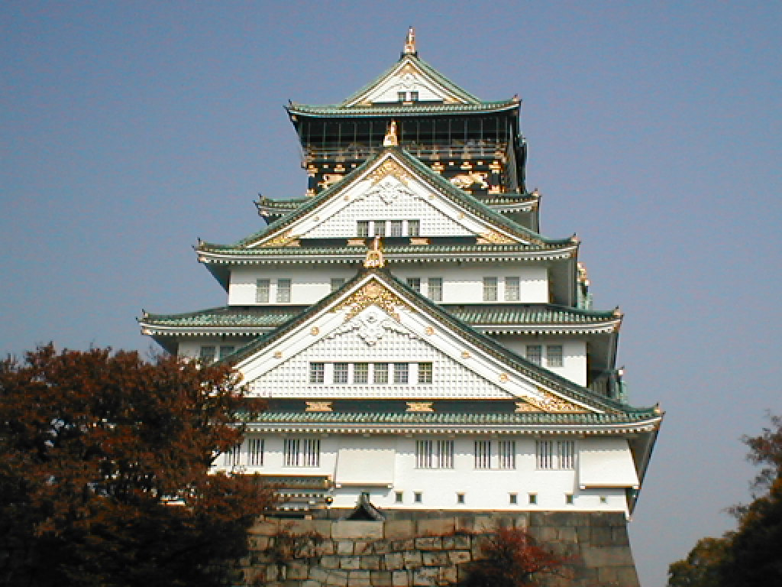

Osaka Castle has a big park around. There are many people (④enjoy ) sports, (⑤paint ) pictures and (⑥have ) lunch in the park. There are also many flowers we can see in each season. Osaka Castle is one of the famous places [⑦visit / many tourists ].
＊tourist 観光客

問１：①、⑦の[ ]内の語句を並べかえて英文を完成させよう。
① we see | ⑦ many tourists visit
問２：②～⑥の（ ）内の語を適切な形に変えよう。
② built | ③ called | ④ enjoying
⑤ painting | ⑥ having
Step 2
次の場所や食べ物について、メモを参考にして( ）内の語を並べ替えて説明しよう。
メモ
・大阪水族館
・水槽で泳いでいるたくさんの種類の魚
・通りを歩いているペンギンたち
- This is Osaka Aquarium.
We see (①in the tanks / many kinds of fish / swimming ).
And we sometimes see (② walking / on the streets / the penguins).
- tank 水槽
① many kinds of fish swimming in the tanks
② the penguins walking on the streets
メモ
・大阪スタジアム
・わたしたちが昨日見た野球の試合
・わたしたちが先月行ったコンサート
(2) A lot of events are held in Osaka Stadium.
For example, (① we / the baseball game / watched / yesterday)
and (② we / went to / the concert / last month ) were held there.

① the baseball game we watched yesterday
② the concert we went to last month

Let’s challenge!

ポールと久美が文楽について対話をしています。この対話の翌日、ポールは日本に来ている留学生の集まりで、文楽についてスピーチをすることになりました。ポールになったつもりで、スピーチの構成メモを参考に、30語～40語程度の英語で原稿を書いてみよう。

Kumi: Paul, this is a present for you.
Paul: Thank you. Can I open it?
Kumi: Sure!
Paul: Oh, it’s a book about Bunraku. What is Bunraku?
Kumi: Bunraku is the traditional puppet show of Japan.
Paul: When did it start?
Kumi: It started in the 17th century in Osaka. It was popular in the whole Kansai region.
Paul: Why is the puppet show called Bunraku?
Kumi: It comes from the name of a person, Uemura Bunraku.
He opened a theater, the Bunraku-za in Osaka in 1872.
Now, the National Bunraku Theater is in Osaka.
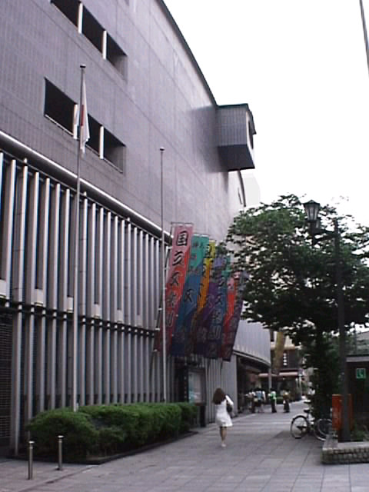
It’s the only one in Japan.
Paul: Is Bunraku well known among young people?
Kumi: Not really. There are usually old people in the theater.
But now more and more young people are
interested in Bunraku.
Paul: Oh, I want to see it some day.
Kumi: OK. Shall we go together next Sunday?
Paul: Yes, let’s.

＊puppet show 人形劇 Kansai region 関西地方
theater 劇場 the National Theater 国立劇場

ただし、書き出しはThis is a book …という書き出しで書いてください。
This is a book my friend gave me.
原稿の構成メモ
・久美からもらった本
↓
・文楽とは
↓
・文楽座とは
↓
・文楽への関心について
It is about Bunraku.
Bunraku is the traditional puppet show.
Bunraku-za is a theater opened in 1872.
More and more young people in Japan are interested
in Bunraku.

